Poster Presentation Examples

- English Language Teachers’Perceptions of Intercultural Competence

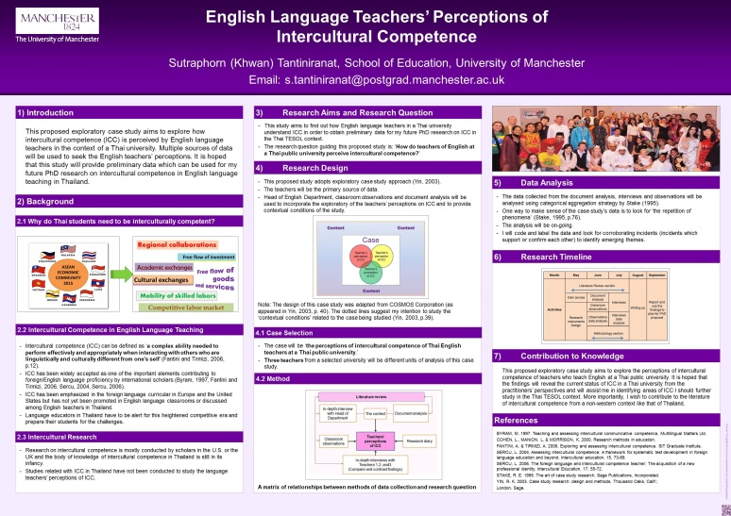

Source:
https://www.google.com/search?q=oxford+university+poster+presentation+on+humanities&biw=1224&bih=571&source=lnms&tbm=isch&sa=X&ved=0ahUKEwipv8nnIbOAhVDKMAKHUcFCOIQ_AUICCgB#imgrc=P01WiMwbDjeq6M%3A [accessed on 23rd July 2016]

- Effect of Microbial Legacy on Nitrogen Cycle and Restoration Success

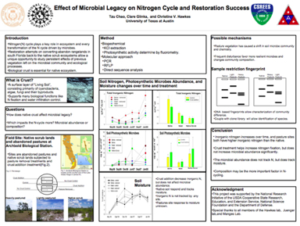

Source:
https://www.google.com/search?q=effect+of+microbial+legacy+poster&source=lnms&tbm=isch&sa=X&ved=0ahUKEwil8qGhmIbOAhWoAsAKHeocAfoQ_AUICCgB&biw=1224&bih=571#imgrc=ZIhuWLEGYfbbIM%3A [accessed on 23rd July 2016]

- Cooling Effects of Dirt Purge Holes on the Tips of Gas Turbine Blades

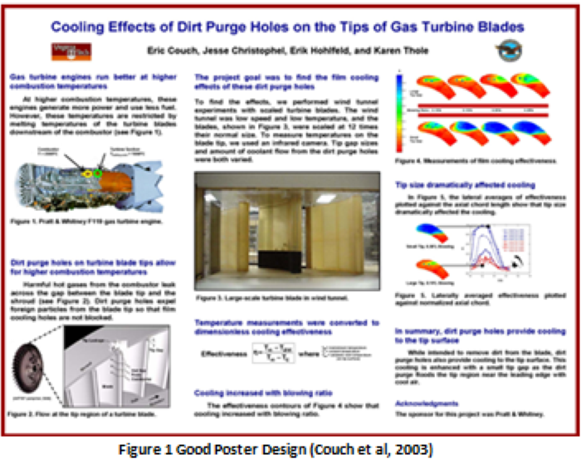

Source:
https://www.google.com/search?q=cooling+effects+of+dirt+poster+presentation&source=lnms&tbm=isch&sa=X&ved=0ahUKEwiij73Wl4bOAhXmAMAKHe8xD4kQ_AUICCgB&biw=1224&bih=571#imgrc=SU4bnJ_mr_pjzM%3A [accessed on 23rd July 2016]
- Comparing Vegetation across Topographic Positions in Two Watersheds at the Susquehanna Shale Hills Critical Zone Observatory

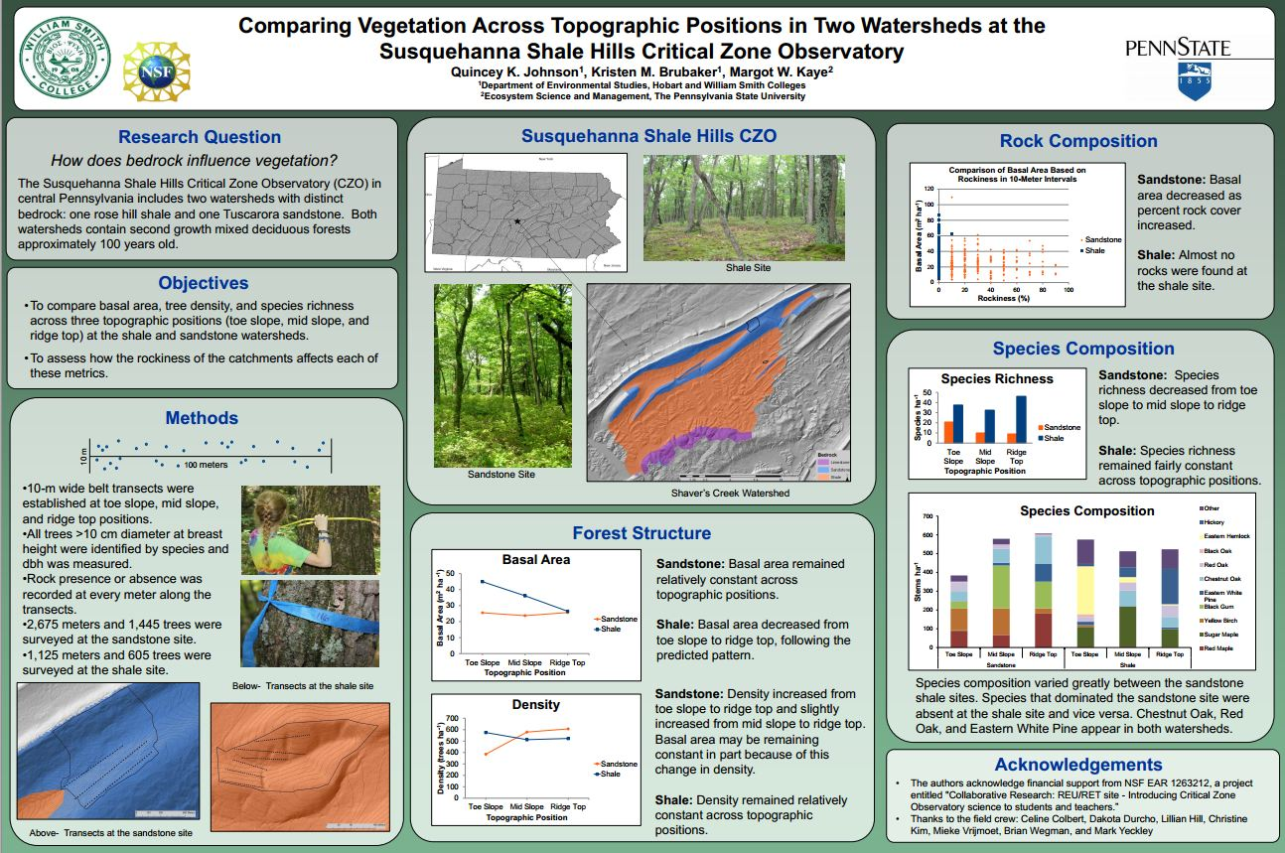

Source:
https://www.google.com/search?q=effect+of+microbial+legacy+poster&source=lnms&tbm=isch&sa=X&ved=0ahUKEwil8qGhmIbOAhWoAsAKHeocAfoQ_AUICCgB&biw=1224&bih=571#imgrc=ZIhuWLEGYfbbIM%3A[accessed on 23rd July 2016]

- Bereavement Support for family careers of people living with Motor Neuron Disease

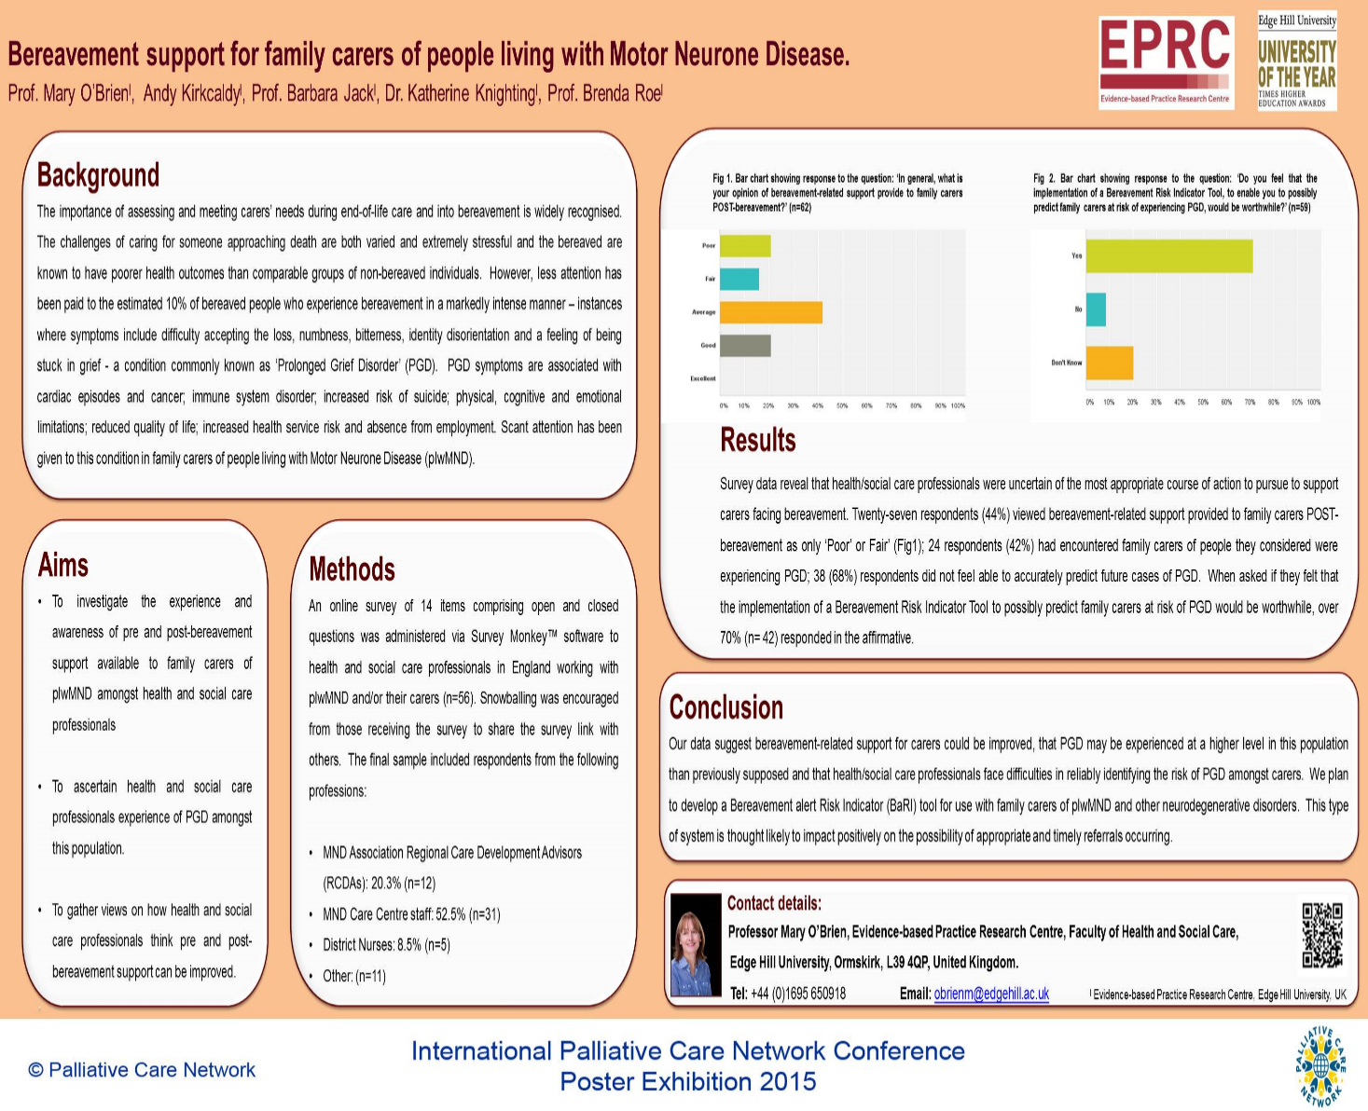
Source:
https://www.google.com/search?q=LEeds+university+research+poster+sample+literature&biw=1224&bih=571&source=lnms&tbm=isch&sa=X&ved=0ahUKEwjTwpD5m4bOAhUGDsAKHUIPB5kQ_AUICCgB#imgrc=-oPjITQbHIYwPM%3A[accessed on 23rd July 2016]

